Contents
1 LLC 1
L1. Are Ads hyperlinked? Can they be hyperlinked? 1
L2. Section on home page for free sessions? Links directly to player presentation vs going to session details? Note: This requires multiple clicks/repetitive information. DMA had this previously and would like to carry this over. 1
L3. Once logged in – this does not display on the top toolbar that I am logged in, or who I am logged in as 2
L4. Featured Events/Special offers – can I list more than 3? 2
L5. CHRIS TO CHECK IQ+ AND PLAYER PRESENTATION LINKS 2
L6. Media Legend – “Course” and “Denotes Audio or Video Presentation synched to PPT slides” do not show the images. 2
L7. Clicked the “Home” tab in the nav bar, and the Featured Sessions content has disappeared: 3
2 PLAYER 8
P1. Player issue: 9
P2. Volume control does not collapse once expanded 10
P3. Session Content page has old audio synch icon: 10
P4. When I click on the “Acquisition and Retention - Part I” session, I get a “There is no date in xml” error. The session does not play: 10
P5. When I change the width of the browser I am in, IE, the player shifts to the left or right, but if shifted to the left, it cuts off the panels to the left: 11

LLC

Are Ads hyperlinked? Can they be hyperlinked?

Section on home page for free sessions? Links directly to player presentation vs going to session details? Note: This requires multiple clicks/repetitive information. DMA had this previously and would like to carry this over.
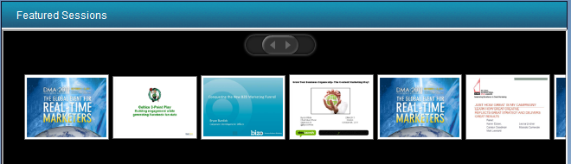

Once logged in – this does not display on the top toolbar that I am logged in, or who I am logged in as
(only if you log in through My Account area… say for example, you log in through checkout cart… there is no name, ONLY in places with My Account pane)
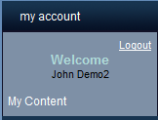

Featured Events/Special offers – can I list more than 3?

CHRIS TO CHECK IQ+ AND PLAYER PRESENTATION LINKS

Media Legend – “Course” and “Denotes Audio or Video Presentation synched to PPT slides” do not show the images.
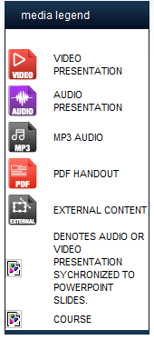

Clicked the “Home” tab in the nav bar, and the Featured Sessions content has disappeared:

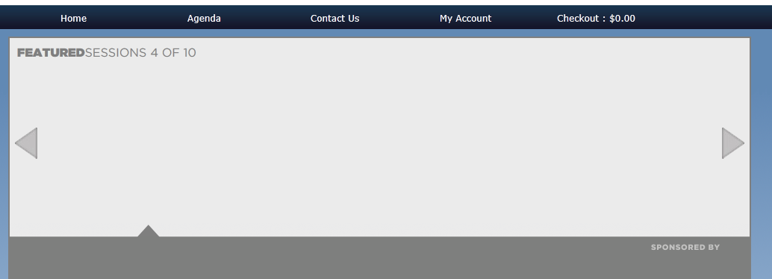

Checkout – removing item from drop down list is not intuitive, even with the message that comes up when you hover over the item
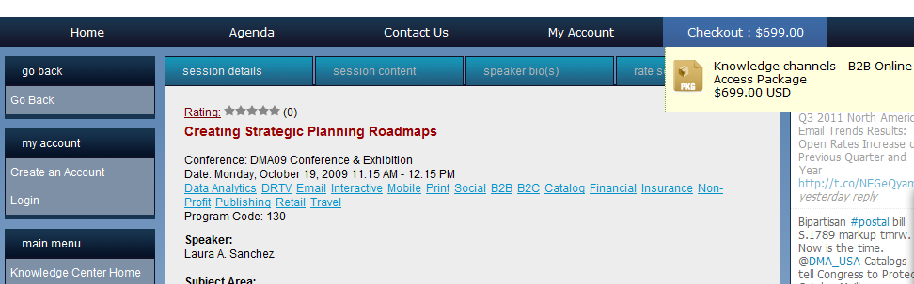
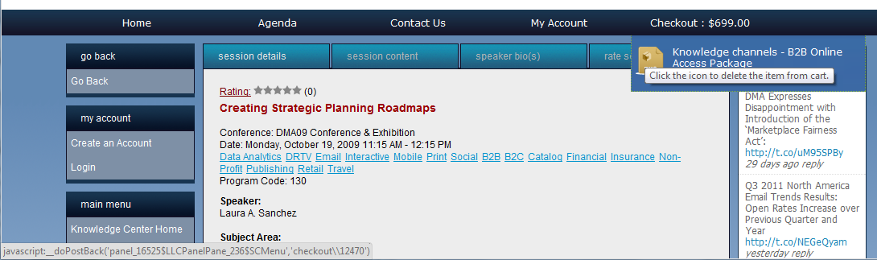

Checkout – when I log in with Demo user from checkout area I do not land in the checkout cart, but rather, the DMA knowledge Center panel
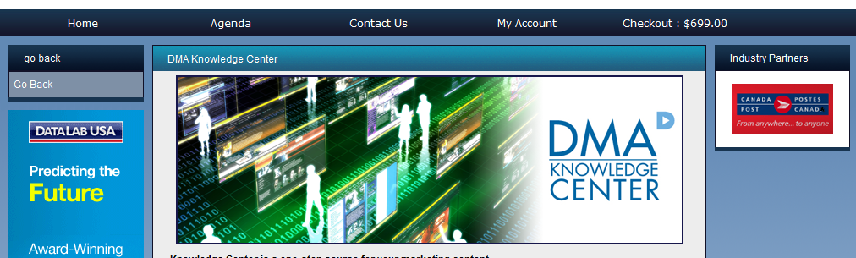
See the below screen of normal checkout area on NAGC shopping cart page – I think that this is a setup issue
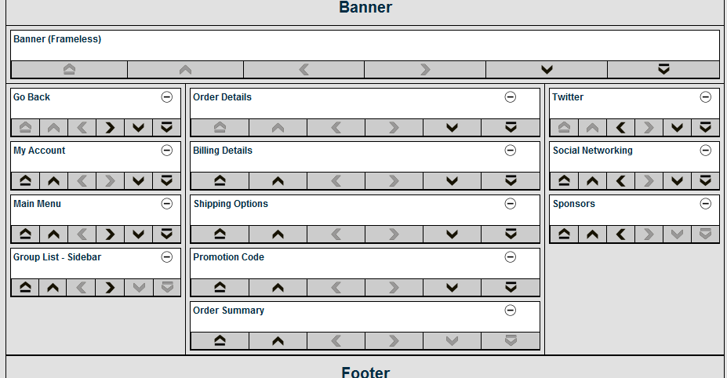
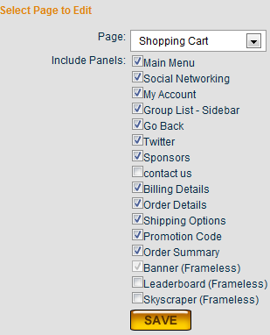

Big Multiview logo is incomplete at bottom of the knowledge center page once I logged in from checkout area and landed on knowledge center
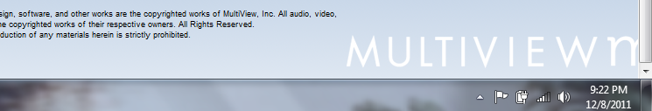

Session details> other offers still has old aud/PPT icons
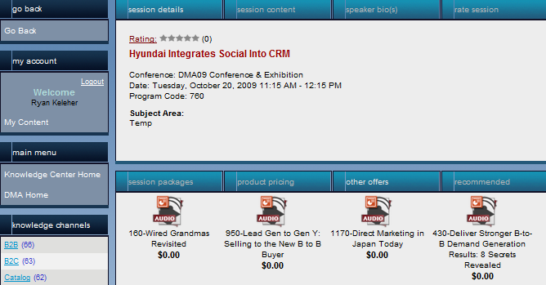

Wrong aud/ PPT icons also in session details> session content
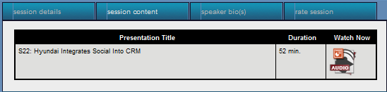

Session details> recommended tab for items doesn’t have any message in it if there are no items listed
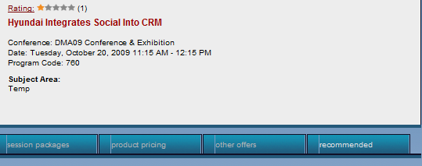

On home page> clicked on conferences link under a featured session, session information disappeared and tiles froze, unable to click on them. Scrolling arrow frozen also. Small Ad disappeared
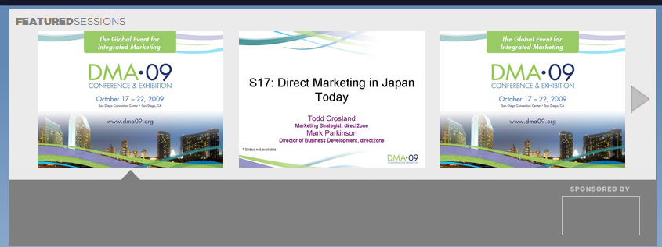

Links to groups under the featured session did not work on first click, only the second click – also the link with the session name didn’t work on first click
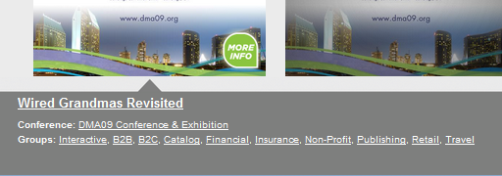

Menu bar > My account drop down becomes dis-coloured when graphics become misaligned
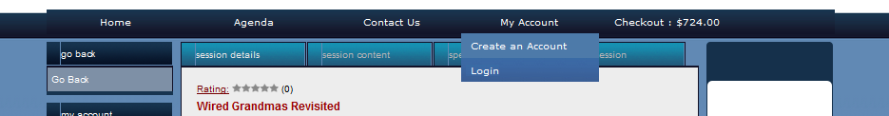

Menu bar tabs don’t act on first click once tabs and graphics are misaligned like in L16 screenshot

PLAYER

- Player issue:

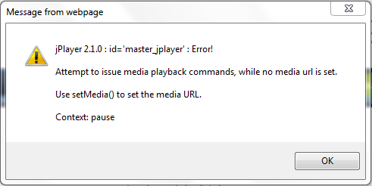

*in addition (Ryan) – I logged out from Demo and logged back in with Ryan to test a featured session called…“creating strategic planning road maps for customer…” despite being logged in with a new user’s account the player seemed to be set to 00:16 before even starting. The player also pauses about 1 second later on its own. Perhaps this is what the error meant? Also, the player deck says now playing with play button on, but presentation is paused.
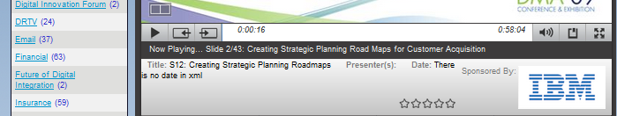
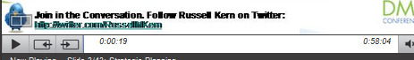
Ex #2
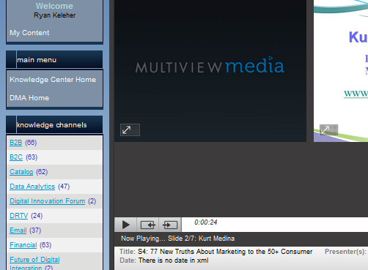

- Volume control does not collapse once expanded

- When I click on the “Acquisition and Retention - Part I” session, I get a “There is no date in xml” error. The session does not play:



- When I change the width of the browser I am in, IE, the player shifts to the left or right, but if shifted to the left, it cuts off the panels to the left:

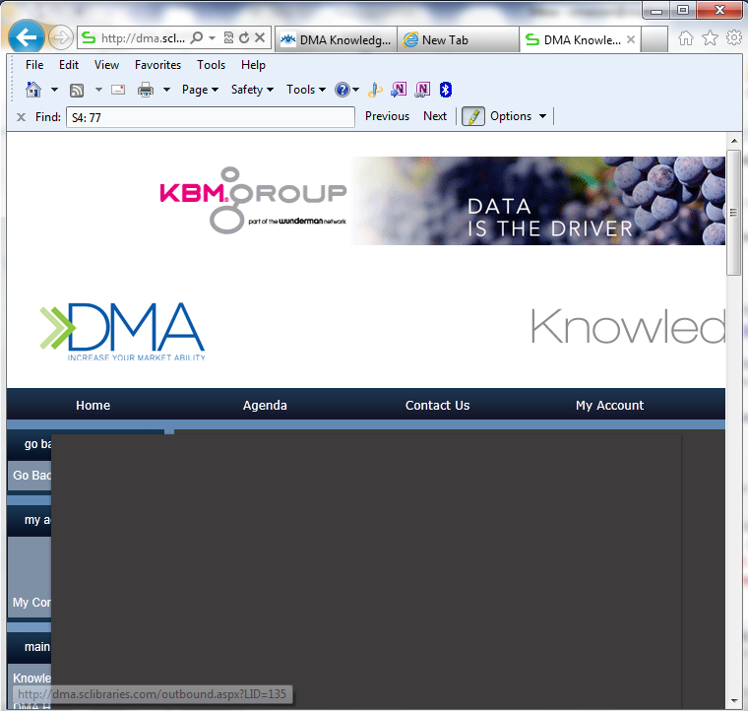

- I logged in, clicked on the first aud/PPT icon, my video did not start automatically (see P7 screenshot).

- Also, from P6 scenario, the player was covering the session list title bar as seen below. This went back to normal after I expanded and collapsed it once… however, all of the menu title bars had graphic bugs after (screen 2)

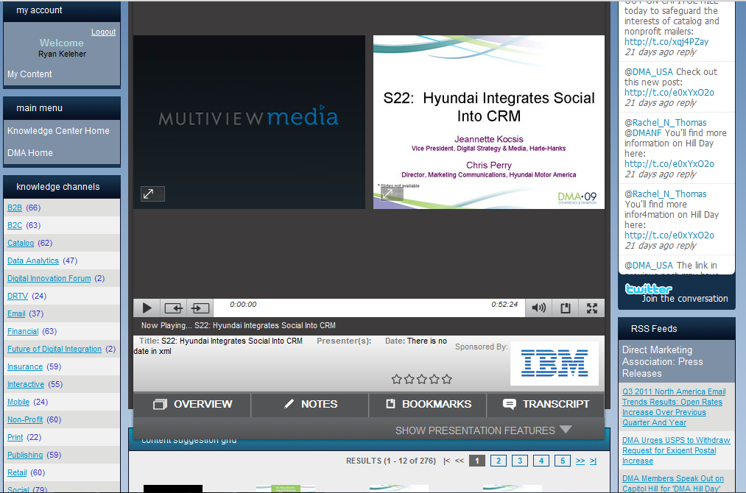
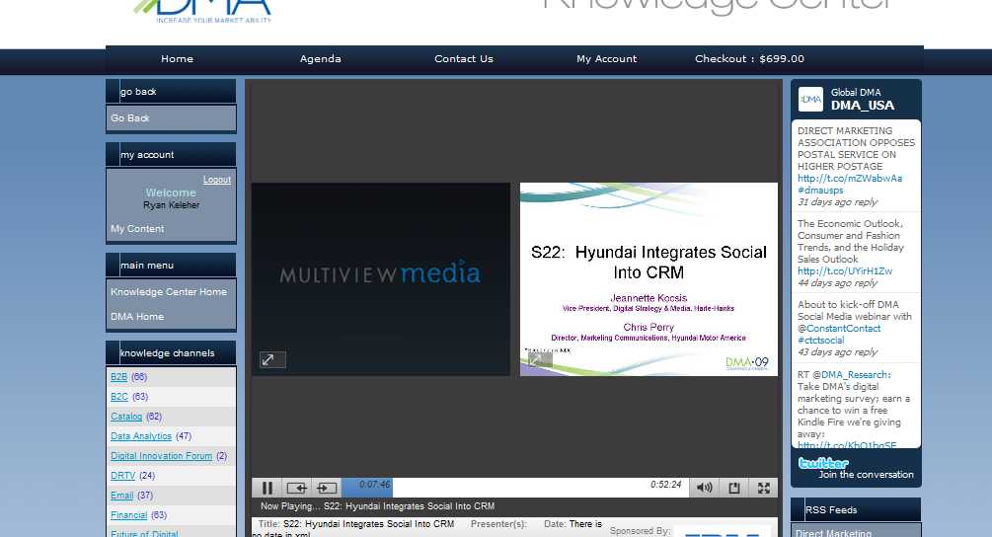
- Show Presentation Features expandable list is very large compared to the contents of the “overview” tab

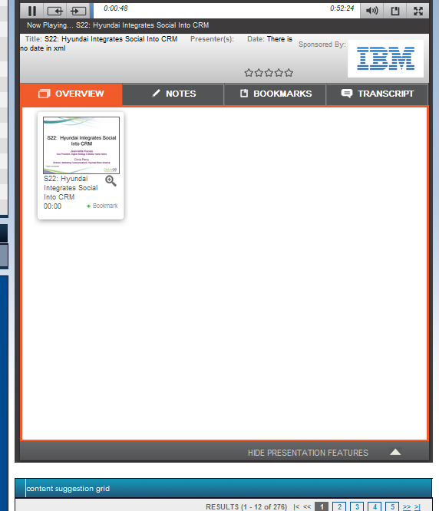
- When I expanded Show Presentation Features, the title bar called “content suggestion grid” below had glitch in graphic (see P8 screen)

- Bookmark button on the player deck does not appear in the bookmark tab – only way to bookmark is in the “overview” tab… also the icon on player deck isn’t intuitive

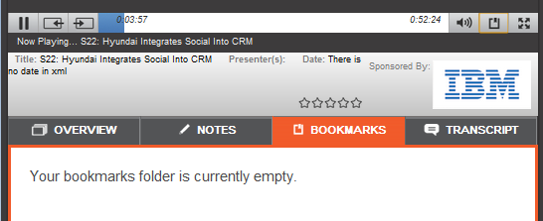

- Minimize icon in the full screen player view has “full screen” message

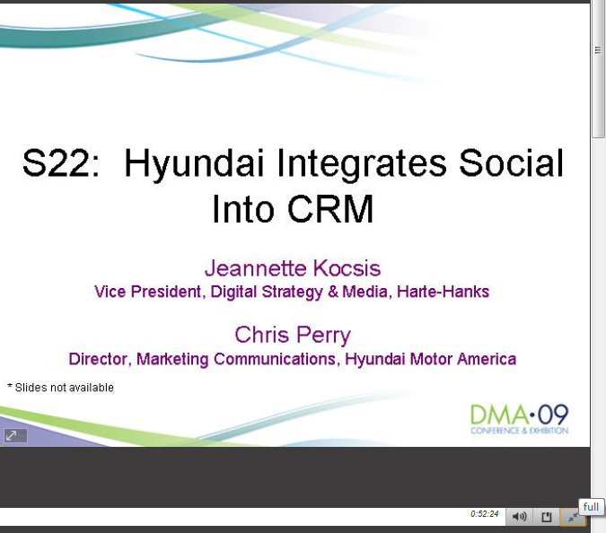
- I entered the normal text below into the “notes” tab of player, pressed save and got an error message

1223143Ч¢βфђёяѠџћЮЯабЩ
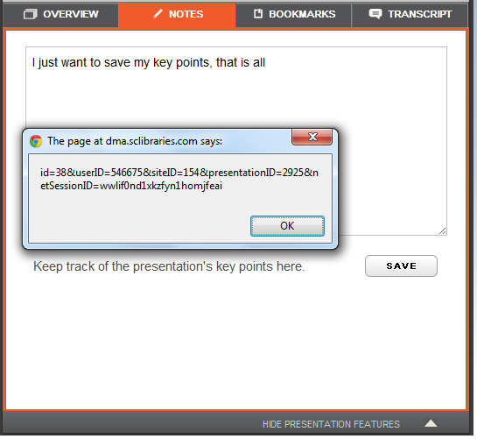
- After navigating player skin for a while, came back to overview tab, and slide was greyed out

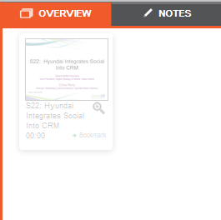

- After entering notes, bookmarks and clicking “go back” to My Content list while watching a presentation, I then clicked on icon to watch the same player presentation, my presentation wouldn’t load - reproducible

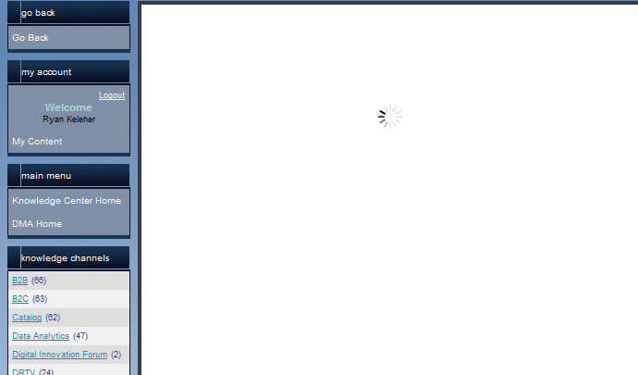
- Softconference player in featured session “Creating Strategic Planning Roadmaps” – preview, no pause, stop, or any functionality… Also, since the player seemed to fully load slides, it could have played full presentation instead of just preview

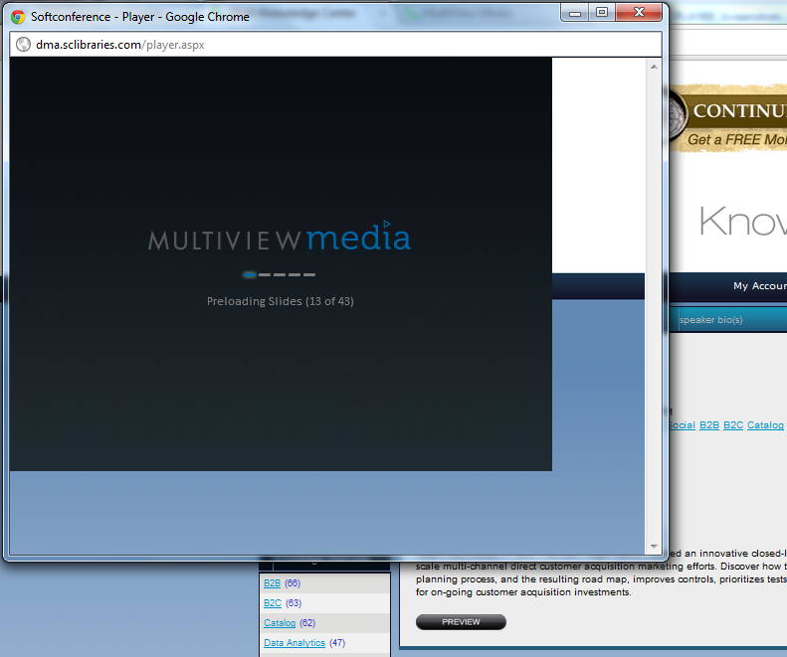
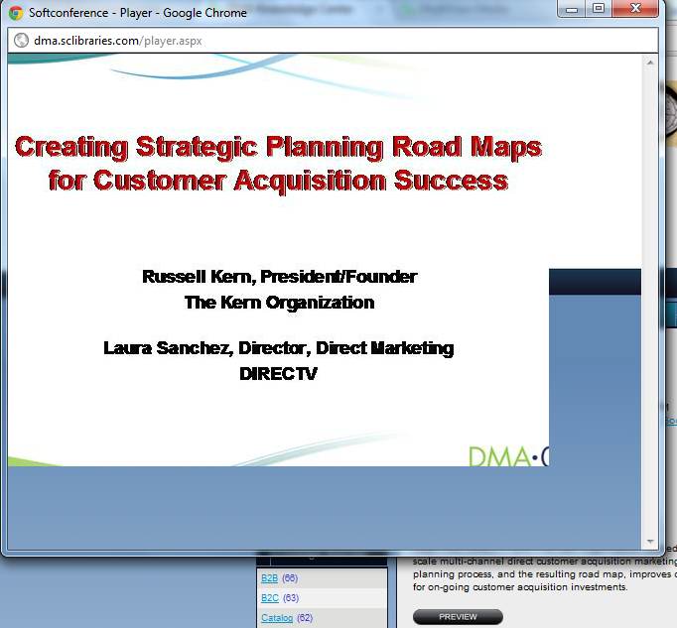
- Star ratings in the player deck cause error message, and after clicking OK on error message, the whole site froze, and so I went to sleep

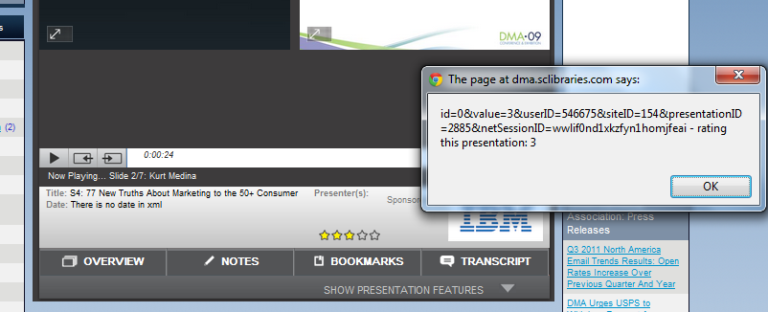
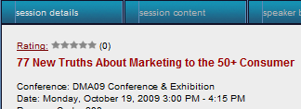 didn’t mention in burn down list that star rating in player isn’t connected to rating on the session details…

